SIMATS ENGINEERING
JAVA PROGRAMMING
LEVEL 2 EXAM
Name : Subiksha U
Reg no : 192424135
1.
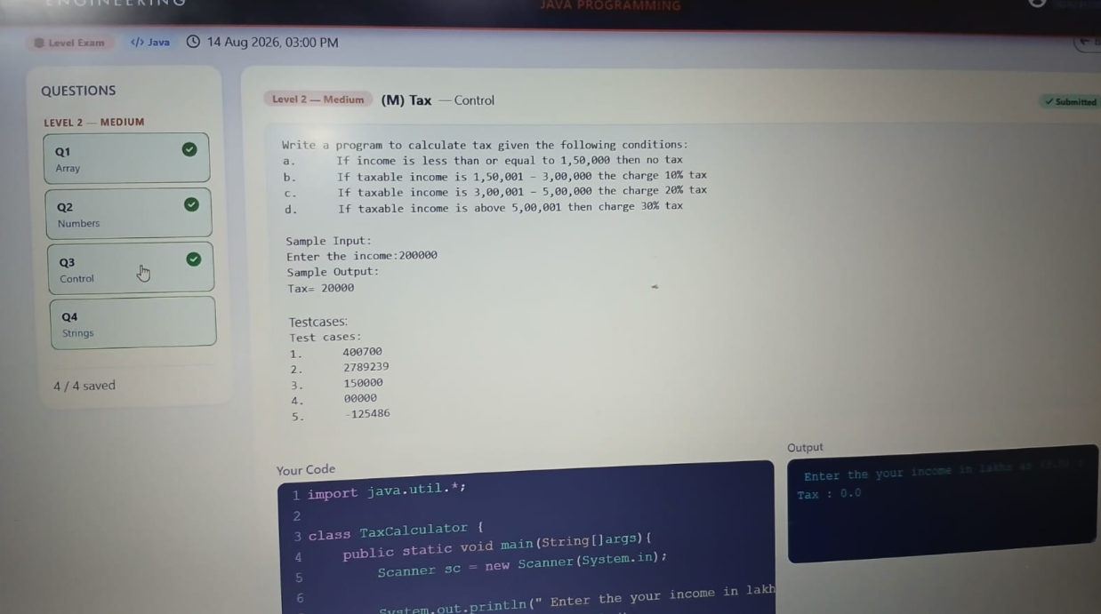

2.
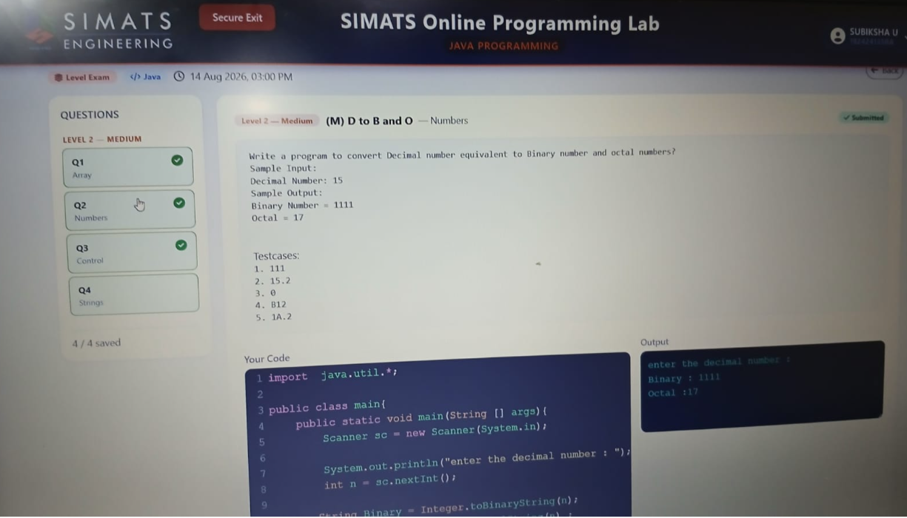

3.
